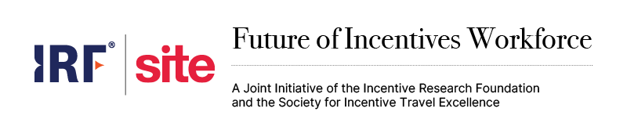Guest Lecturers Introduce Your Students to the Incentives Industry

Incentive travel represents over 7% of the business events industry, and the larger incentive industry represents $176b worldwide. Do your students know about incentives as a business tool and a career path?

The incentives industry is a dynamic field that focuses on motivating and improving performance through various reward programs. These programs are designed to drive profits, boost employee performance, and increase engagement. Despite the industry's significant impact, there is often a lack of awareness about business case for incentive programs as well as the diverse career opportunities in the incentives field.
To address this, the Incentive Research Foundation and the Society for Incentive Travel Excellence have developed engaging curriculum modules that industry professionals can use to introduce the incentives industry to your students. We can help arrange for guest lecturers to come to your classrooms to present the curriculum and share their personal experiences and career journey.
Flexibility is built into this program. Contact us at info@theIRF.org and we can put you in touch with an incentive professional in your area who could spend a class session providing an overview of all the incentives industry has to offer.

